Project :- data analysis of store data

Objective :- store want to make annual sales report for 2022 . so vrinda understand their customer grow their sales in 2023

Sample question :-

Data cleaning :-
:- Check null value :-
Ask yourself:
- Is this column important?
  - Yes → don’t blindly delete
- Is null meaningful?
  - Yes → keep
- Will removing rows bias data?
  - Yes → replace instead
:-Data inconsistent :- data is not right format
Gender case :- m , men , women , w

Solution :- Filter that column --- m----(ctrl + f ) replace the value with men .

--------------------------------------------------------------------------------
Data processing ;-
:- age relation :- age groups

Problem :- if the formula place in the excel it is slow down the system
Solution :- so do copy ---- paste special

:- extract the month form the date

-------------------------------------------------------------------------------------
Data analysis
• pivoit table
Month ---- sum of amount ---- count of order

Chart :- combo ---- secondary axies
Degin : remove the subtotal ad grand total

• pivoit table
Sales :- men and women

Chart :- pie

• Pivoit table
Keep top10 ship - in state

• Pivoi table
Age group ( men and women )
Age group men women

(right click on cell ) Show values as :- Create grand total percentage easy to read

• pivoit table
Channels where the cutomers is coming

• add slicer in the dashbored
Click on the chart which is build by a slicer
Problem :- tha slicer is connected to only that chart so you hve to connect wih another
Soluion :- right click on the chart ---- REPORT connection

• ISIGHTS AND NEXT ACTION
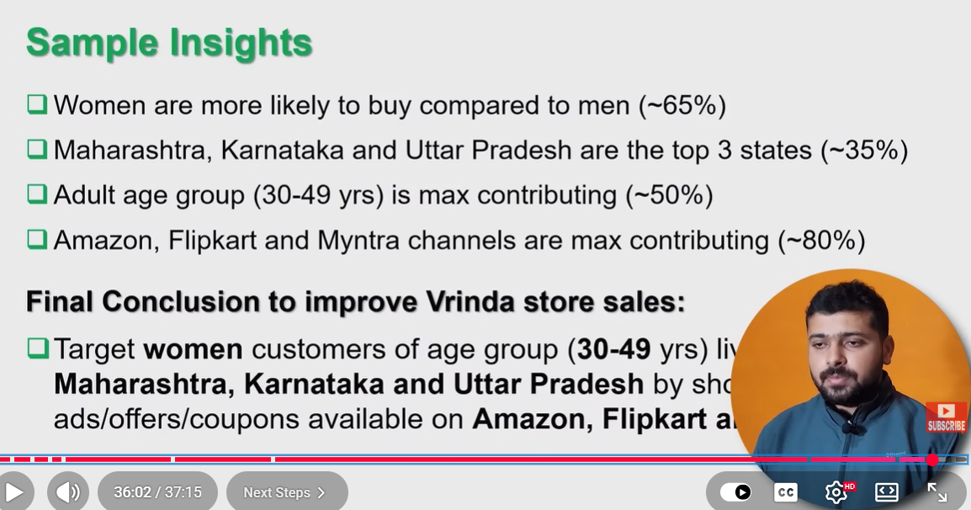

Problem :- there is a problem when I click on the protect sheet my slicers is also block there is not movement happen in it
Solution :-
Select the option use autofilter
Right click on the slicer then clck size and properties then click locked option

Deployment :-
One drive and + protected sheet

